Village of Buena Vista
1050 Grand Avenue
Buena Vista, SK
S2V 1A2
Phone: 306-729-4385 Fax: 306-729-4518
Email: buenavista@sasktel.net

Agenda
Special meeting
6.30pm Tuesday, May 25th, 2021
Regina Beach Arts & Craft Centre,
223 Centre St, Regina Beach

Call to order:

To be discussed:

INTENTION TO AMEND
THE VILLAGE OF BUENA VISTA
ZONING BYLAW NO. 7/16

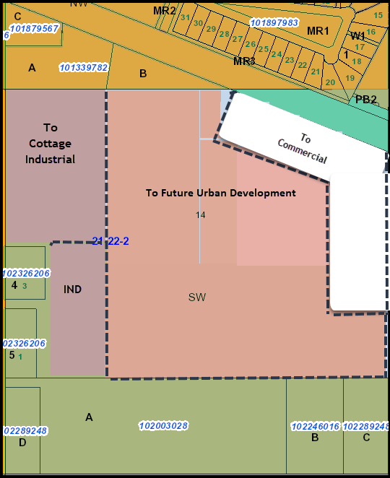

Adjournment:

