Quill Lake Update

The following information is to keep you informed of the events that have taken place since our last communication in August. We (LMLSG) have partnered with representatives from the Lower Qu’Appelle Watershed and a representative from the Sask Beach Council to oppose the Quill Lake Drainage / Diversion Project, as presented by the Quill Lake Watershed Association.

Newspaper articles have been placed in local newspapers.

We requested a meeting with the Minister but have not had one. Our group met with the NDP Environmental Critic to discuss the issues and solutions.

In August, our small group travelled to the Quill Lakes to observe flooding in that area. We visited the spill point for the Quill Lakes; the point where water from the Quills would drain south if it got that high (almost 1m above where the levels are now). The area is a shallow wide and dry saline area. We saw the saline Kutawagan Lake and a dam, operated by Ducks Unlimited Canada situated at the north end of the saline Pel Lake. This dam stores water in Pel Lake reducing outflows north to the Quill Lakes. THE QLWA proposal would see all this water drained south to Last Mountain Lake. We could also see how water levels at the Quill Lakes have dropped 14 inches from the peak this spring – 36 inches below the spill point. Water levels on the Quill Lakes continue to decline.

We saw the salt flats on Pel Lake where water had receded, revealing a salty crust on the ground. It was startling to see the amount of salt left behind after the water receded back on these Lakes. We find it hard to believe that diverting water “from Pell Lake south towards Peter Lake and Last Mountain Lake” would be considered ‘fresh water’ diversion.

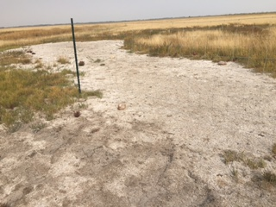

We saw the Water Security office in Wadena that was opened as a result of the announcement in 2016 to close all illegal drainage operations. To date WSA has not issued a single fine for illegal drainage or closed any of the ditches they say they would. Illegal drainage continues.

We saw drained wetlands that can be used to store water. These areas along with others can reduce the amount of water going into the Quill Lakes by 38%, which would both lower the Quill Lakes levels and prevent the threat of overflow to Last Mountain Lake. We saw fields with large earth-moving equipment being used to drain more water, (sloughs and marshland), digging channels so more water can easily drain into the Quills. We saw where existing ditches had been deepened to allow more drainage into the Quills. New drainage ditches continue to be dug without anyone from WSA stopping or fining them.

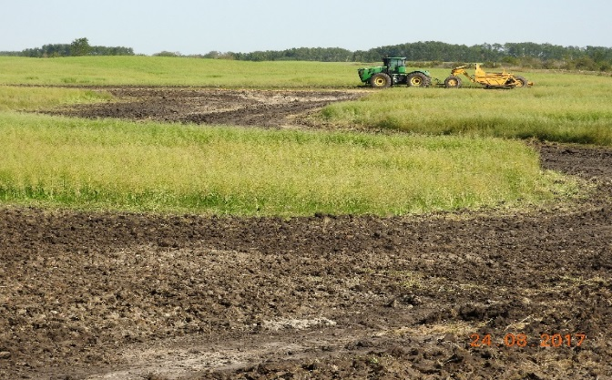

Wetlands are natural storage spaces and have been present on the prairies for thousands of years. Water that producers are draining from wetlands belong to the crown; it's not theirs to drain – a license is required. However, wetlands continue to be drained by landowners illegally without a license.

We have sent letters to both levels of government describing the reasons why draining / diverting water from the Quills would be disastrous to the quality of lake water; fish and aquatic life would be at risk; we would see an increase in algae bloom due to added TDS and agricultural runoff (nitrates and phosphates), the effect it would have on recreational activities, and the potential for more flooding.

In our letter to Honourable Dustin Duncan we asked that a commission be established where a delegation of experts could review all flood mitigation options, so that a responsible decision can be reached, one that does not have a negative impact on our lakes and rivers.

The QLWA have presented their drainage / diversion plan as “urgent”, one that must be started immediately to avoid a natural spillover from the Quills into LML. Lake levels are declining and a hasty decision is often the wrong decision. However it is important that a solution be reached that is cost effective, safe to the environment and one that will serve long term. Expertise in all areas of the environment, public consultation and cooperation with all levels of government is key in finding the answer.

For your information, I have attached the link below which shows the irrevocable damage phosphorous can do to a body of water.

http://www.cbc.ca/news/canada/manitoba/lake-winnipeg-phosphorus-algae-blooms-1.4293366

We can’t stress enough the importance of public input regarding this issue. Simply put, draining water from the Quills to LML will be disastrous to our lake and those living downstream. For your convenience, I have provided email addresses below, and ask that you continue to voice your objections to the QLWA Diversion and WSA’s lack of enforcement and express your support to use the water storage areas that exists in the Quill Lakes watershed to the following officials.

susan.ross@wsask.ca
dustin.duncan@gov.sk.ca
premier@gov.sk.ca
ralph.goodale@parl.gc.ca

Thank you.

Submitted By: Sherry Forsyth
On Behalf of the Last Mountain Lake Stewardship Group

